You will only be able to access and print off your certificate when you have fully completed the ASB Tools and Powers E-learning Module (all sections showing complete) and have marked complete the Evaluation sections (via the Learning Pool page).
When you access the e-learning course via the ‘Derbyshire Learning On-line’ site, you are able to monitor your progress through the course by the progress bars at the bottom of each section on the Home screen. To complete the module, the progress bar for each section has to be whole.
In the example below you can see that one section is complete, but the second section is only partially complete. You must complete all sections of the course for your training record to show completed.
When all four blocks are completed, click here to return to Learning Pool
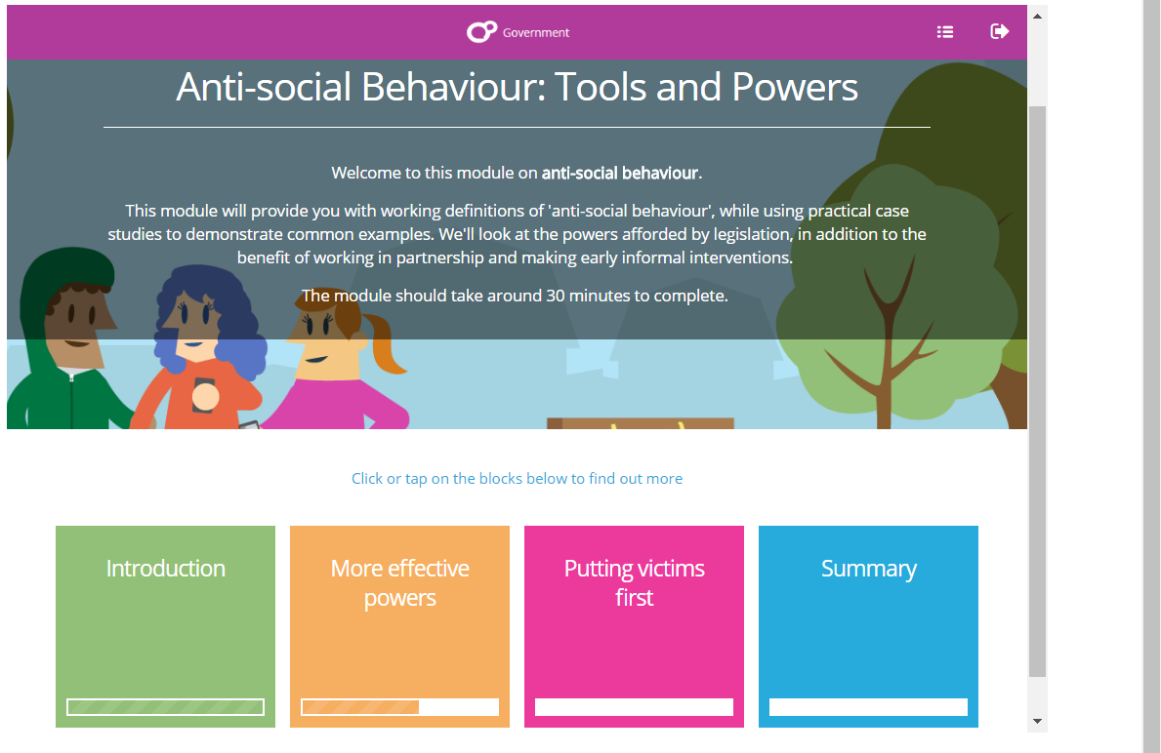
This progress bar is showing a striped area meaning that this section is completed.
Progress bar is showing section not started
Progress bar is showing a partial completion.
Scroll down using these two sliding bars to reveal content throughout the module.
To begin the module, click into the first box – ‘Introduction’. Make sure you do not miss any content on each page. Scroll down using the sliding scroll bars on the right-hand side, until you cannot scroll any further, completing all the activities as you go.
Only once you are at the bottom of the page, and have completed all the activities, should you click the ‘Next’ button.
The next page will explain what to do if you have missed something, but are not sure what you’ve missed.

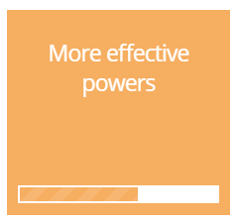
Left Click on the section where it is showing you have missed bits. In this example, ‘Types of Hate Crimes and Incidents’.
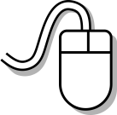

If you have not started a section then no progress bar or part progress bar will be displayed. To identify the bits missed in this section left click on the Progress bar
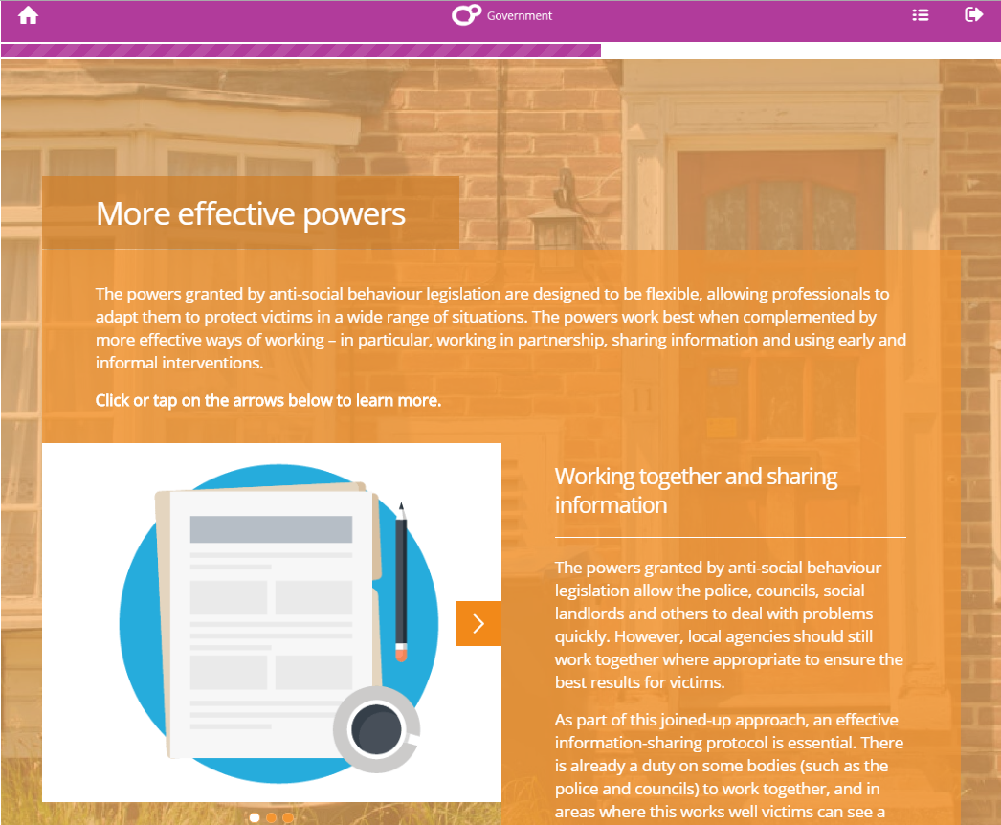
In each section of the course the Progress Bar will be displayed along the top of the screen. Left Click on the Progress Bar.
The bits missed are displayed down the right hand side of the screen. They can be identified by a white rectangle (completed sections show in stripes). Left click on a white link, e.g. ‘Community Protection Notice’, to take you straight to a section which has been missed.
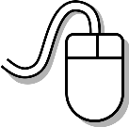
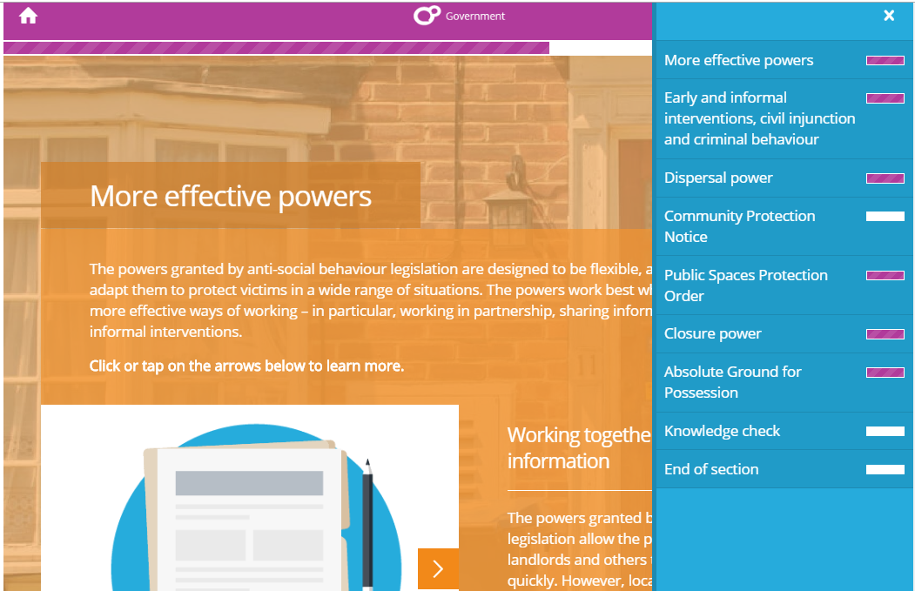
Click on each white box to take you straight to the bits you have missed.
Revisit each section missed and complete.
In the example below you would need to click on the arrow (circled) and read the information revealed. The number of dots below the image signifies there are four bits of information to read. You may need to click on pins/drop down sections or answer questions depending on the activity you missed. You may just need to read the information.
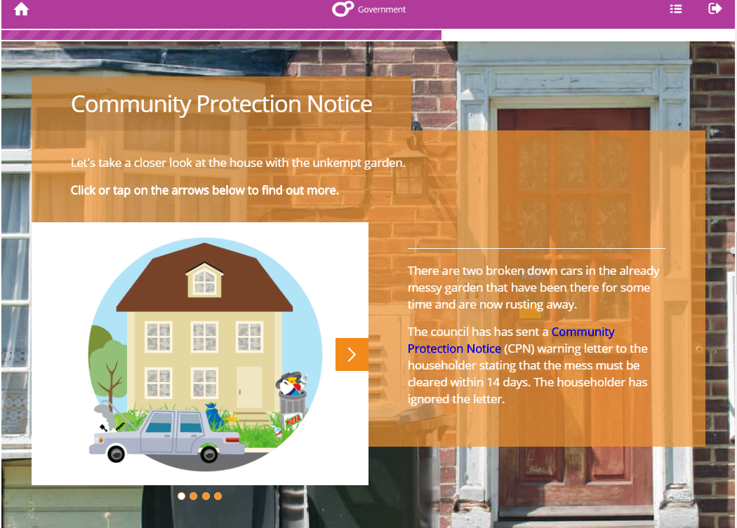
Four dots indicate you’ll need to click the arrow, circled above, three more times.
As each bit is completed the Progress Bar will extend across the screen.
On each page, make sure you scroll down and complete all the activities on that page, before you click onto the ‘Next’ button, which will take you to the next page.
When you have completed all the activities missed on a page, use the home button to return to the main menu and repeat for any other sections that are not fully complete.
After you have completed all sections, return to the main menu, then exit the course by clicking on the button located at the top right of your screen.
You will then return to the main Learning Pool page where you MUST complete the ‘Evaluation’ and print off your certificate.
This is explained in more detail overleaf…
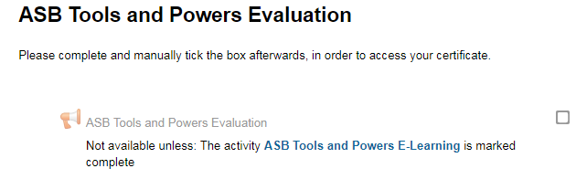
Click on the web-link to access and complete the course evaluation. Register your completion by manually clicking the box.

As you will see above, you can only access the Evaluation if you have successfully completed the ASB Tools and Powers E-Learning Module.
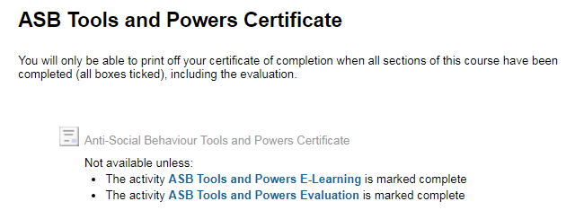
Click on the web-link to access your certificate. You should print a copy for your records.
The Certificate section follows the Evaluation and can only be accessed when you have also marked that your Evaluation is complete, as shown above.
You will only be able to access and print off your certificate when you have fully completed the e-learning module (all sections showing complete) and have marked complete both the Hate Crime Websites and the Evaluation.
If you still have problems accessing your certificate, please email dlo@derbyshire.gov.uk.

