You will only be able to access and print off your certificate when you have fully completed this CSE eLearning Module (all sections showing complete) and have completed the Useful Contacts and Information and Evaluation sections (via the Learning Pool page). See below:
When you access the CSE eLearning course via the ‘Derbyshire Learning on-line’ site, you are able to monitor your progress through the course by the progress bars at the bottom of each section on the Home screen. To complete the course the progress bar for each section has to be whole.
In the example below you can see that the ‘What is child sexual exploitation?’ section is complete, ‘Spotting signs of child sexual exploitation’ is partially complete and the last three sections are not complete. You must complete all sections of the course for your training record to show completed. You are able to revisit the bits you missed by the following method:
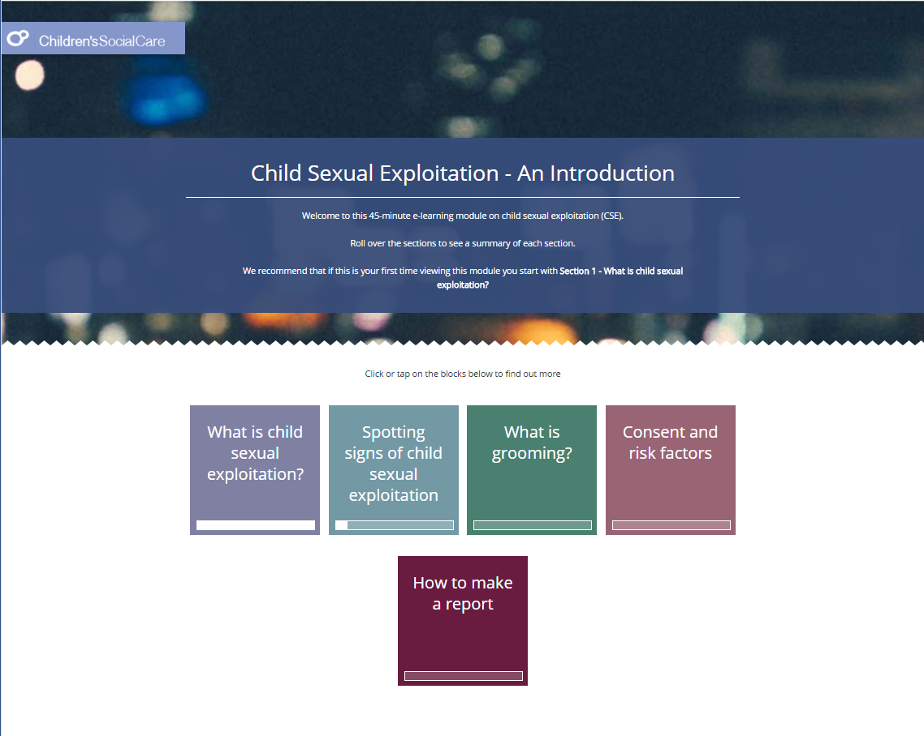
Progress bar is showing section as incomplete / not started.
Progress bar is showing a partial completion.
This progress bar is showing a white area meaning that this section is completed.
To begin the module, click into the first box – ‘What is child sexual exploitation?’.
Make sure you do not miss any content on each page. Scroll down using the sliding scroll bars on the right-hand side, until you cannot scroll any further, completing all the activities as you go.
Only once you are at the bottom of the page, and have completed all the activities, should you click the ‘Next’ button.
The next page will explain what to do if you have missed something, but are not sure what you’ve missed.
Left click on a section where it is showing you have missed bits. In this example ‘Spotting the signs of child sexual exploitation’.
If you have not started a section then no progress bar or part progress bar will be displayed.
To identify the bits missed in this section Left click on the Progress bar (see overleaf)
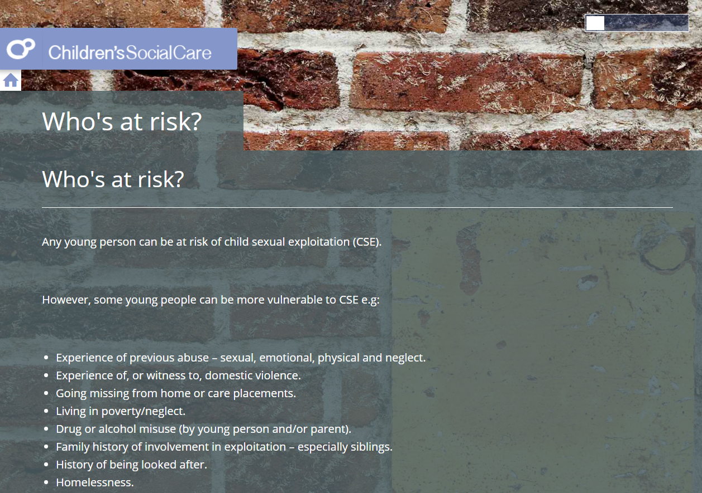
In each section of the course the Progress Bar will be displayed along the top of the screen. Left click on the Progress Bar.
The bits missed are displayed down the right hand side of the screen. They can be identified by a clear rectangle (completed sections show in white). Left click on a link, to take you straight to the bit missed and complete.
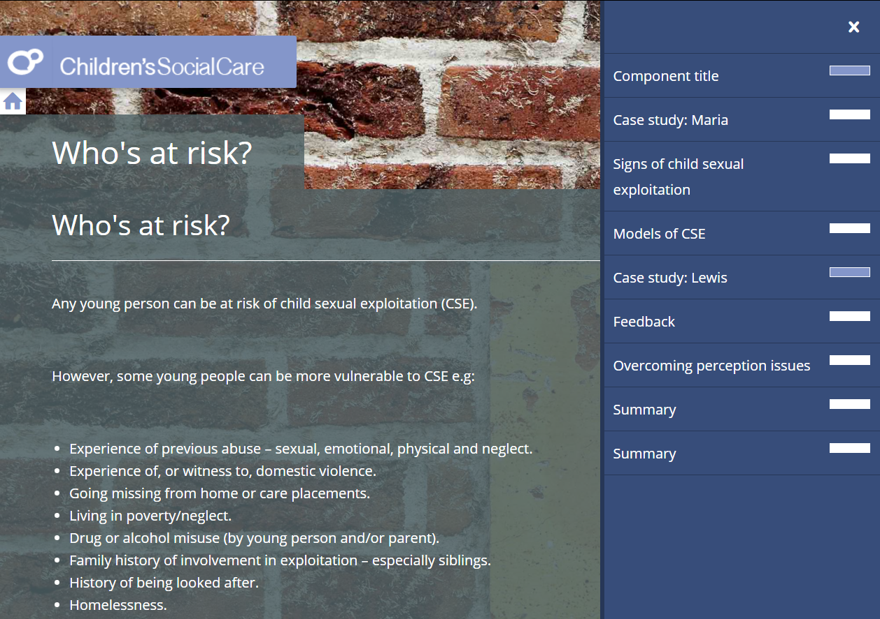
Click on each clear link to take you straight to the bits you have missed.
Revisit each bit missed and complete. In the example below you would need to click on the arrows to progress through the case study and read the information revealed. You may need to click on pins, arrows/drop down sections or answer questions depending on the activity you missed.
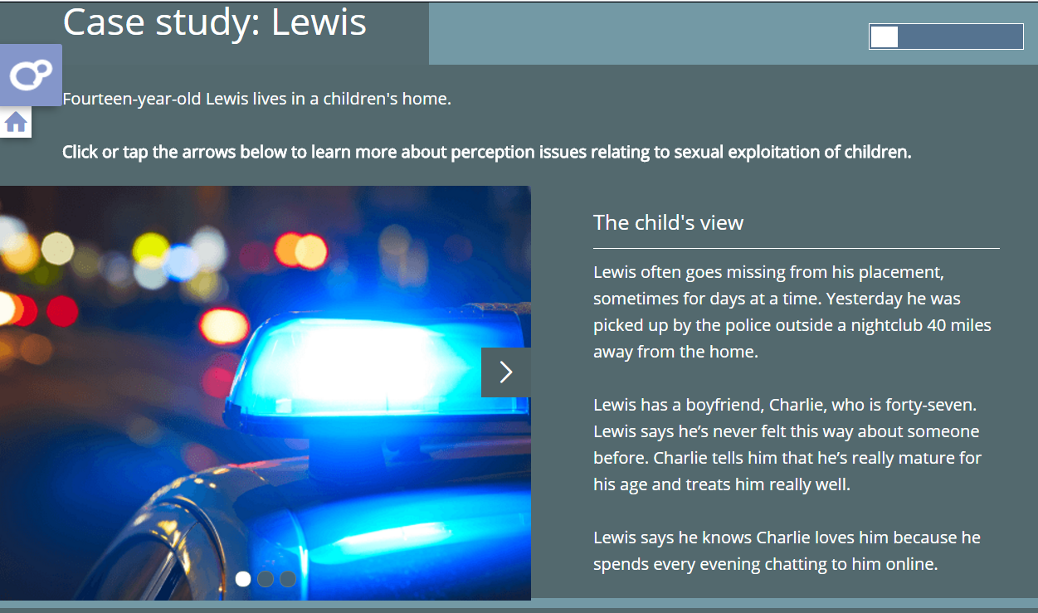
As each bit is completed the Progress Bar will extend across the screen.
When you have completed all the activities missed on a page, use the ‘Home’ button to return to the main menu and repeat for any other sections that are not fully complete.
After you have completed all sections, return to the main menu, then exit the course by clicking on the button located at the top right of your screen.
You will then return to the main Learning Pool page where you MUST complete the following two sections to unlock your certificate: ‘Useful Contacts and Information’ and ‘Evaluation’.

See next page…
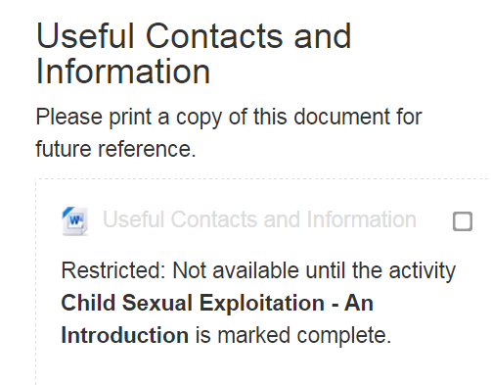
Click on the web-link to access the document. Ensure you print and read the document before manually clicking each box.
You will only be able to access the document when you have fully completed the e-learning module.
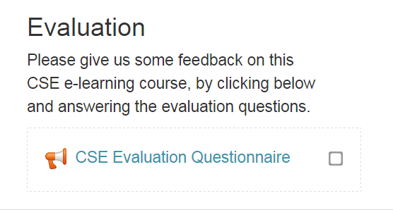
Click on the web-link to access and complete the course evaluation. Register your completion by manually clicking the box.
The certificate section follows the evaluation.
You will only be able to access and print off your certificate when you have fully completed the eLearning module (all sections showing complete) and have completed the and the evaluation.
If you still have problems accessing your certificate, please email dlo@derbyshire.gov.uk.
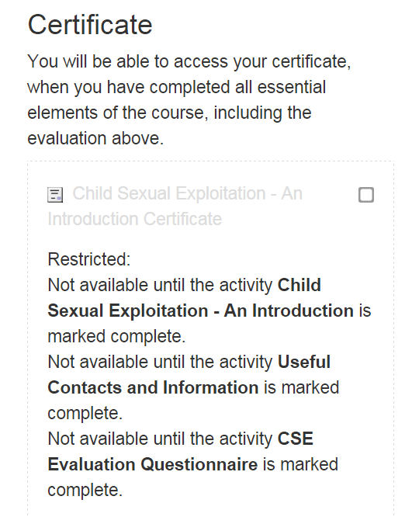
Click on the web-link to access and print off your certificate.
You will only be able to access the certificate when all the activities have been fully completed as described in this document.
If you still have problems accessing your certificate, please email dlo@derbyshire.gov.uk.

